# Market Analysis

## “Who Plays Mobile Games?” – Google Play Research Study, June 2017 (Available at: <http://services.google.com/fh/files/blogs/who_plays_mobile_games.pdf>)

1. 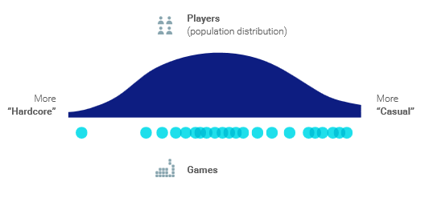“Players are not just casual or hardcore […] These extremes are also associated with a range of demographic assumptions and sterotypes. **The reality is a majority of players fall somewhere between these two extremes along the game playing spectrum**”.
2. “We found that key gaming behaviours and attitudes can be framed as an aspect of social behaviour and/or passion for gaming”
   1. “Social” = “Social influence and social activity”
      1. Learn about new games from my friends playing the game
      2. Recommended by friends/family is an important reason for downloading a game
      3. My friends are playing the game is an important reason to download a game
   2. “Passion” = “interest in games & fandom”
      1. I connect with other players within my mobile game in order to obtain more items/prizes/higher scores
      2. I enjoy collecting items and characters in a smartphone game/ I enjoy collecting virtual items/ cards/ characters within mobile games
      3. I’m always interested in exploring new mobile games
3. 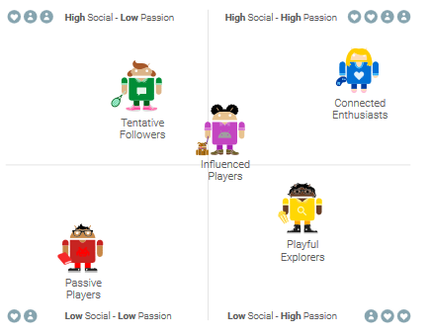The mobile game players segments
4. “The drivers of segment differences are not demographics”
   1. Some demographic differences exist, however gaming needs and behaviours are more “different and meaningful”
5. “Sine genres appeal to specific segments, while others have a more general appeal”
   1. Puzzle games are universally popular
6. “Different segments of users are more likely to use different channels for discovery”
7. “Motivators of engagement go beyond just relaxation and boredom”
8. “Checklist for Developers
   1. Consider the various needs of your players. Unless your game is highly targeted towards a specific demographic group, **don’t fall for demographic stereotypes.**
   2. Take player differences into account when designing your game or adding new features
   3. Tailor your customer acquisition strategy to target player segment.
   4. Tailor engagement strategies to motivate your target player segments.

## “WarTug” Concept

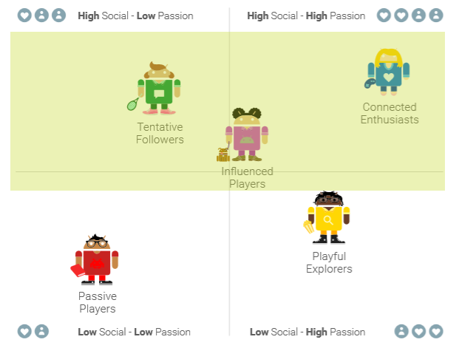As illustrated by the diagram above, our concept best fits into the “high social” bracket of Google’s analysis. This is largely down to our concept being built from the ground up as a multiplayer experience (as dictated by the brief). Consequently, players with a low drive for social interaction within mobile games will likely be deterred from our game.

## Popular Genres Amongst Target Audience

With the target market for our game now clearly established, it is important to consider the popularity of genres among these players. As illustrated in the diagram above, the overall most popular genre across our target audience is puzzle games, followed by action games and strategy games, respectively.

Lifewire Magazine describes the action genre as “[games with an] emphasis on challenging the player’s reflexes, hand-eye coordination, and reaction time. Given that our initial game pitch makes exact references to these mechanics, it is clear that, first and foremost, our game is an action game. Whilst this genre naturally performs well within our target audience, it may be beneficial to analyse mechanics popular within the ‘puzzle’ and ‘strategy’ genres as to further our games appeal.

## Game Discovery/Promotion

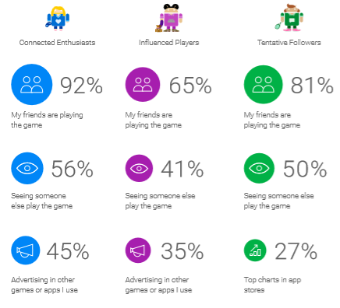As exemplified in the image above, the most popular way an app is discovered by our target audience is through seeing a friend play the game. The next most popular method of game discovery was seeing somebody else play the game (e.g. an acquaintance or stranger on the bus etc…), followed by advertising in other apps and reaching the top charts.

## Other points of note

* Connected Enthusiasts “are all about making progress, testing their skills (both personally and with others) and rewarding themselves with the pleasure of game play”
* Influenced Players “also see playing games and making progress as a reward, but are less focussed on testing skill compared to others”
* Tentative Followers “are less likely to focus on the pleasure of game playing. They see game playing as a way to relieve boredom and relax”.